**Mockup Build**

1. (0.33 pts.) Team short name (i.e., project sponsor name)
   1. Downey1
2. (0.33 pts.) Names of all team members
   1. Corinne Smith, Ryan Yount, Alex Toth, Ryan Brown
3. (0.33 pts.) Up-to-date product mission statement
   1. Dr. Austin Downey needs a bridge shaker that needs to test vibration data, operate at different frequencies, be safe to operate, and leave the bridge undamaged.
4. (1 pts.) CAD illustration of assembled product

1. (1 pts.) Exploded view(s) of product.

1. (2 pts.) Photograph(s) of final mockup build

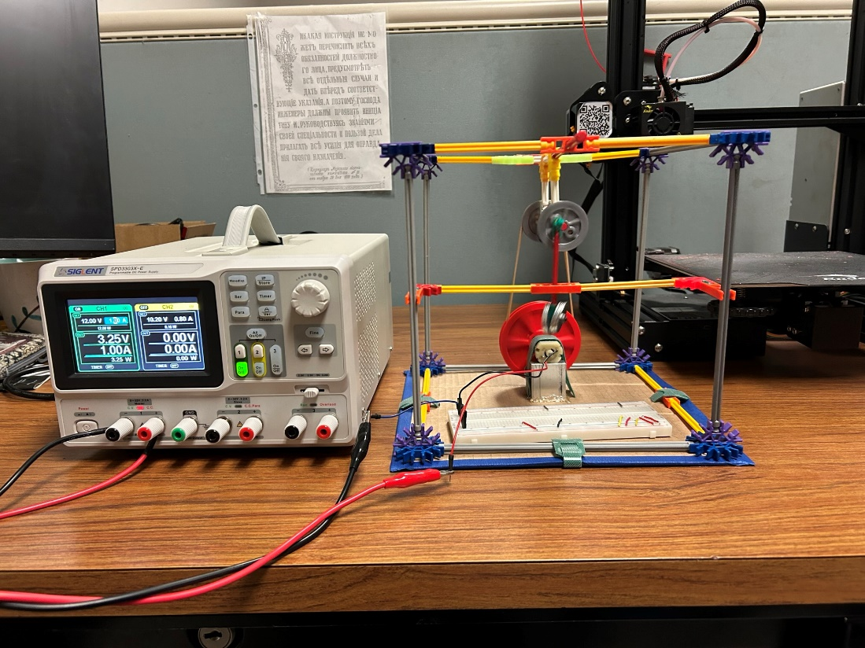

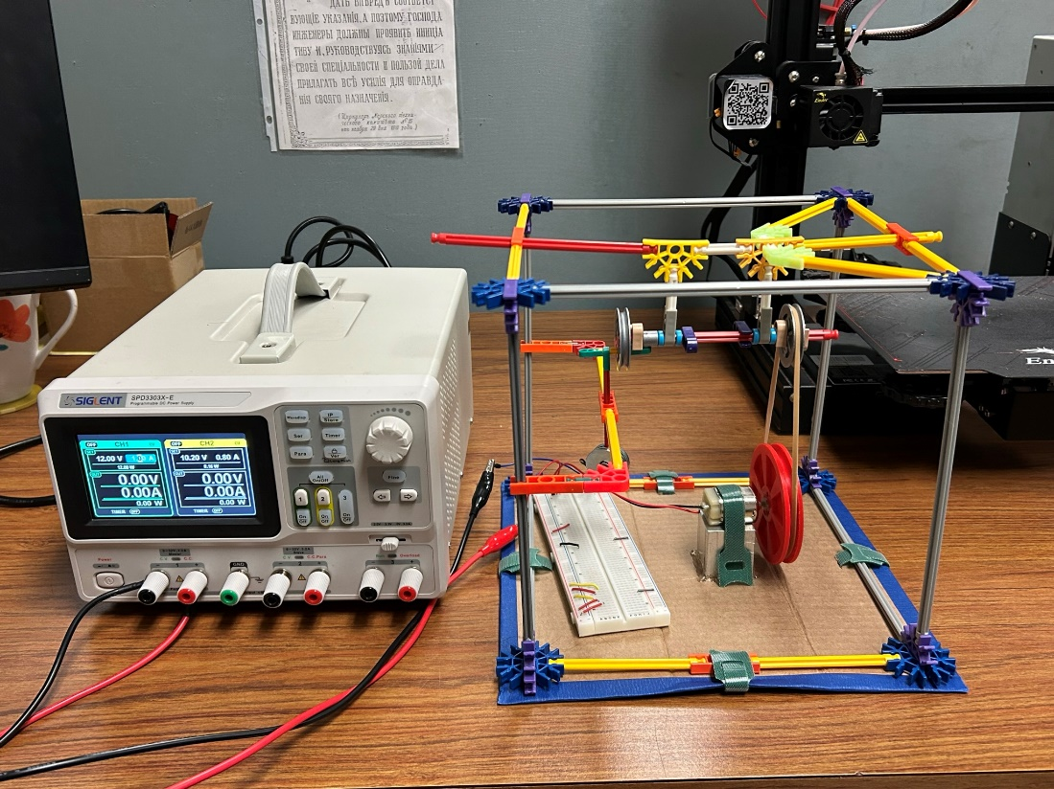

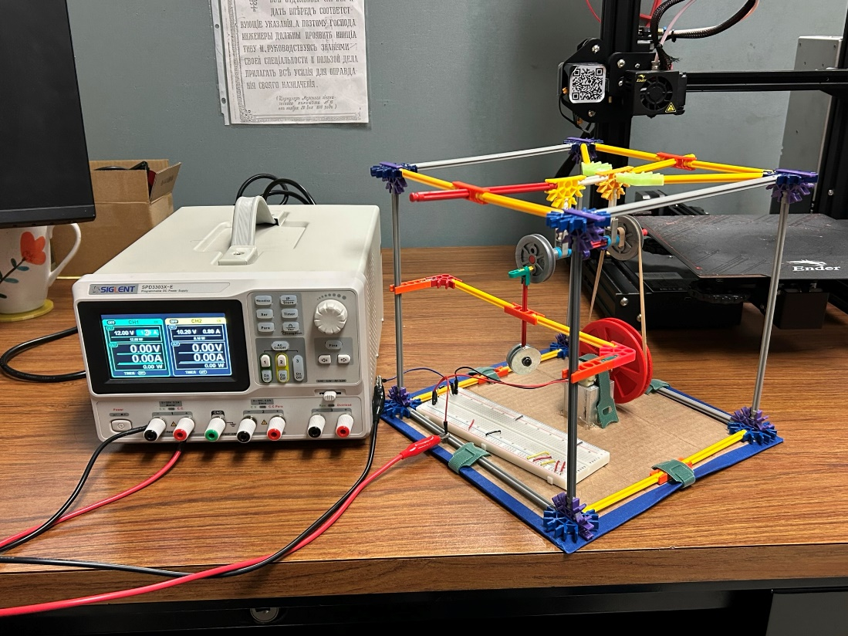

Our mockup in action: [Mockup build in action!](https://youtu.be/3h06Zy0r7BI)

[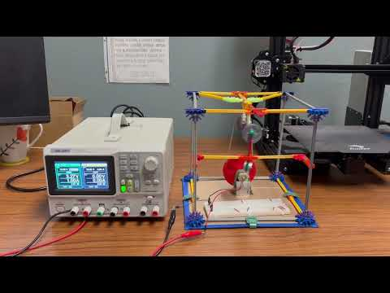](https://youtu.be/3h06Zy0r7BI)

1. (3 pts.) Lessons learned: Explain what this build has taught you (if it is “nothing,” then you haven’t done it right!)… Are parts of the build going to pose a challenge? Do adjustments to original concept or parts need to be made? What is your confidence in the product’s success now? Will it need supplemental bracing? Can it be streamlined? Do you need to quickly find a different technology for one or more functions ? etc., etc.
   1. This build has taught the group that bracing for the shaft and weight will be critical to the success of the product. The group built a functional model using “K’nex” and a small DC motor to replicate the motion the mass shaker will go through to produce vibrations. In this experiment the group was able to pinpoint week spots in the design. This includes the shaft bracing, motor bracing under tension, the brackets holding the frame together, and the linkage connected to the weight. The original design made use of connections to the base plate for the main transfer shaft, the shaft connecting the gear to the linkage driver, but upon further investigation it was found that for ease of mounting and stability the shaft should be suspended from the top of the frame. This option allows more mobility for the shaft when discussing positioning and ease of fabrication. In addition to the shaft being suspended, it was determined by the group that the implementation of guide rails for the weight would be crucial. In the mockup build, the weight connected to the linkage exerted force in a lateral fashion and was not completely axial. For this to be fixed, a two-linkage system and guiderails will be explored to transition the energy into a more vertical manner.
   2. Another issue found from the mockup build is ensuring that the connection of the frame to the platform will not have screws or fasteners protruding on the bottom, which will hamper its ability to transfer adequate force and induce equalized vibrations to the bridge. The connections to the platform must also be strong enough to ensure stability of the frame which will hold and stabilize all moving components.
2. (2 pts.) Changes you will make to original design as result of this build (again, if your answer is “nothing” you didn’t do this correctly!). Changes you might make may include (but not limited to): sequence of the build compared to how you did this one, part geometries/positions, compacting or expanding geometries to better accommodate needs, fastener location(s), number of fasteners, sizing of functional components (e.g. pipe diameters, pumps, blowers, heat exchangers, etc.), technology to satisfy an identified function, addition of bracing, shelling solid/heavy parts, etc.
   1. Mounting tactics have been a topic of conversation of the group. The design was changed to implement a suspended mount for the shaft to reduce the footprint of the shaft bracing. With the shaft bracing, another issue came to light. The connections to the frame must be heavy duty and strong. The weight moving up and down produces a substantial amount of excess vibration and deformation in the shaker frame. This could be in part to the “K’nex” being made from a cheaper plastic material. With further research the group was able to find 80/20 40 series extruded aluminum that will suffice for the build. This material will keep the shaker in the parameters for weight while also providing more than enough strength to withstand the forces of the mechanism. The issue comes from the brackets holding the frame together. Dr. Downey encouraged the group to explore 3D printed brackets. A bracket was designed and printed for the purpose of fitment. After the fit was found to be adequate, an FEA was done on the bracket to see the displacement and stress put into the bracket. The results were within reason, therefore 3D printed brackets will be used going forward. Lastly, there was discussion about reducing the height of the contraption. The original height was slated for 2.5 FT. This was to give room for the large pinion gear that would be needed to reach the frequency specified by the sponsor. The group found a motor that would supply enough RPM to reduce the pinion size, therefore reducing the overall height.